Anil Kumar Dwivedi

Security Guard Management system

**DDL Commands**

**Create Database**

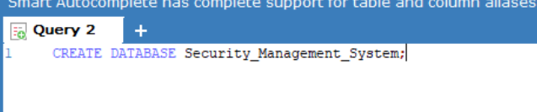

**Creating Security_Department Table**

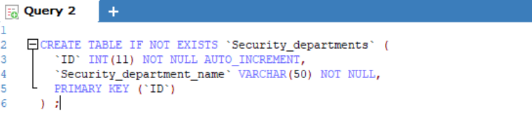



**Creating Security_Quard_Details Table**

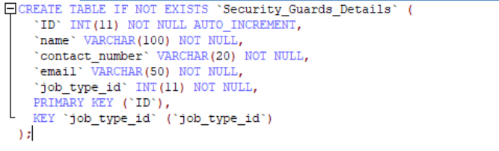



**Creatig Guard_department Table**

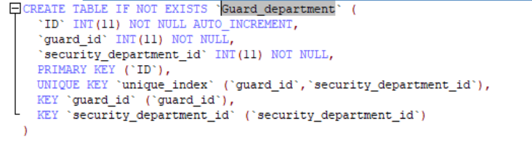

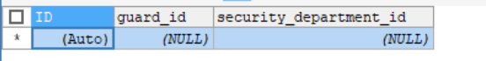

**Creating guard_type Table**

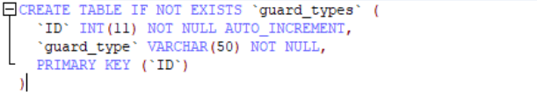



**Creating Salary Table**

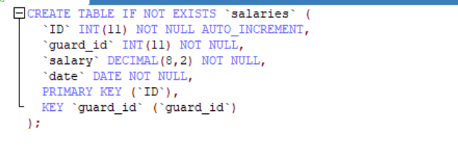

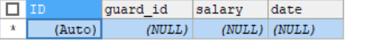

**Altering Tables and adding constraints**

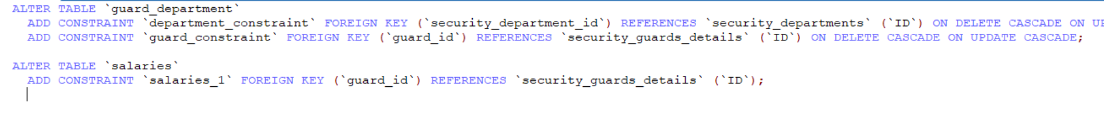

**Droping the Table guard_demo**

**Before**

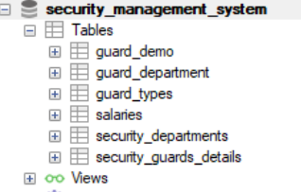

**cammand**



**After**

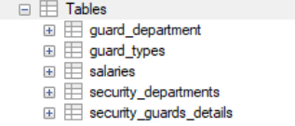

**Select Cammands**

